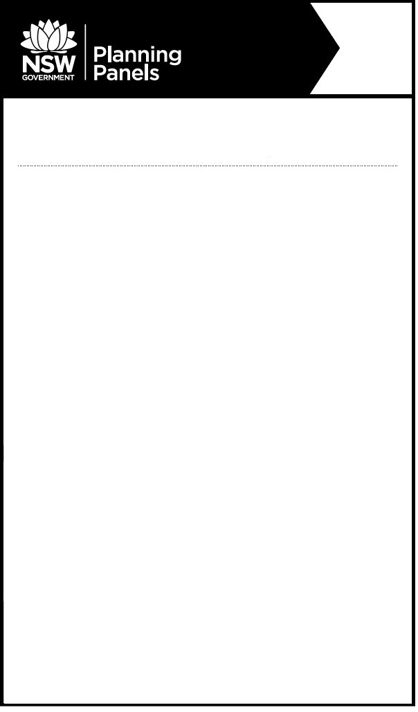

Notice of Public Meeting
Sydney North Planning Panel

The panel will meet to determine the following:
- PPSSNH-107 – Ryde – LDA2020/0199 - 1 Railway Road Meadowbank 2114 – Demolition of existing structures and construction of a mixed use development comprising four buildings ranging in height between 6 and 7 storeys over 3 basement levels. The mix uses will contain 133 residential apartments, a boarding house with 162 rooms and 4,255m² of commercial floor space. Parking for 419 cars is proposed.
When: Wednesday, 21 July 2021 at 10:30am
Where: The meeting will be held by public teleconference due to COVID-19 (Coronavirus) precautions
Relevant documents will be available on the Planning Panels website www.planningportal.nsw.gov.au/planningpanels at least seven days before the meeting.
To register to speak or to listen to this meeting, please contact the Planning Panels Secretariat before 4pm on Monday, 19 July 2021 02 8217 2060 or email enquiry@planningpanels.nsw.gov.au. You will be provided the phone number and code to enable you to join the public teleconference once registered.

Any person may listen to the public teleconference.
The panel is required to make an audio record of the meeting and make the recording publicly available on the Planning Panels website. You should be aware that this may include your personal information if you are presenting to the panel.
For more information: (02) 8217 2060
www.planningportal.nsw.gov.au/planningpanels

